NORMALIZATION

DEFINATION :-

* Normalization is a technique to **remove** or **reduce** redundancy from a table.
* Normalization is a process of **organizing** data in a database to eliminate data anomalies, such as **redundancy**.
* In simple terms, it involves breaking down a large, complex table while maintain data relationships.
* Normalization is commonly used when dealing with large database.
* Normalizationisimportantbecause**, it reduces redundancy, improves query performances, minimizes update anomalies, enhances data integrity.**

**TYPES OF NORMALIZATION :-**

1. **1NF**: This is the First Normal Form in which a relation contains an **atomic value.**
2. **2NF**: The second normal form used for the normalization process. A relation in 2NF must be in 1NF, and all the non-key attributes depend on the **primary key** in the Second Normal Form.
3. **3NF**: It stands for Third Normal Form, wherein if a relation is in 3NF, it must be in 2NF, and there should be **no** **transition** **dependency**.
4. **BCNF**: BCNF stands for **Boyce-Codd Normal Form**, which is stronger than 3NF.
5. **4NF:**This is the Fourth Normal Form which doesn’t contain any value dependency. A relation that is in 4NF also comes in BCNF.

1. **5NF:**5NF stands for Fifth Normal Form, where the relationship should be in 4NF to apply the fifth normal form, this **normal** **form** **doesn’t** **contain** **any** **dependency**.
2. **6NF:**It stands for Sixth Normal Form, which is not a standardized form of normalization. Therefore, it isn’t used nowadays and may give a clear and standardized normalization in the future.

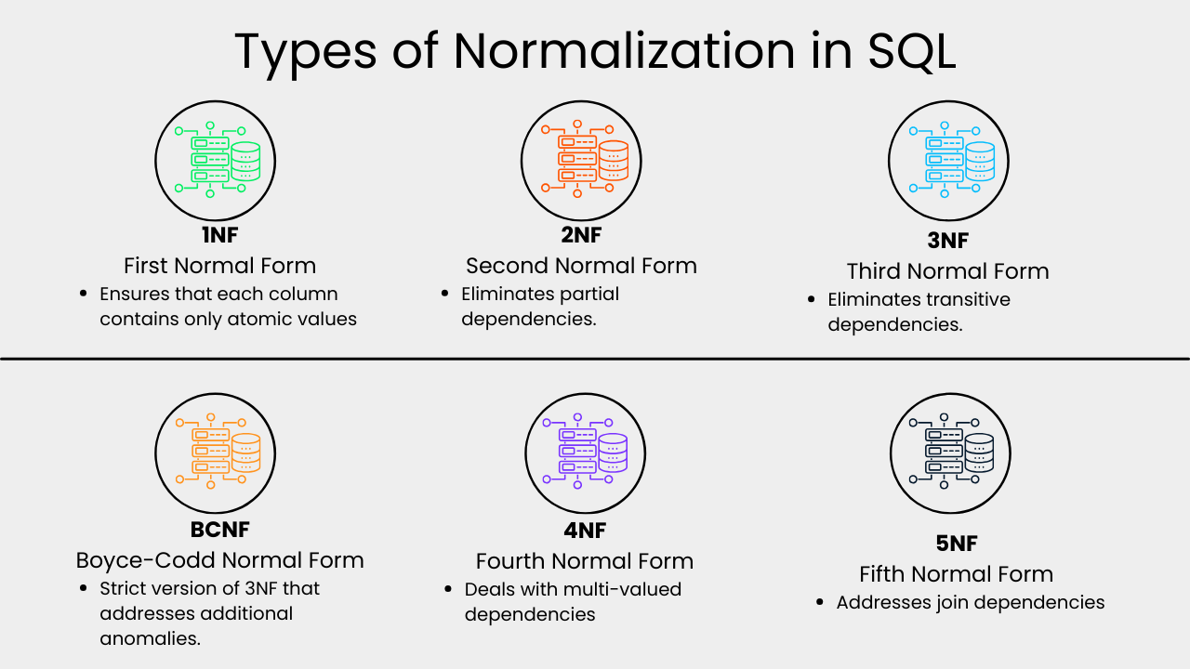**DIAGRAM** **OF** **NORMALIZATION**

**ADVANTAGES** :-

* Reduces redundant data.
* Provides data consistency within the database.
* More flexible database design.
* Higher database security.
* Better and quicker execution.
* Greater overall database organization.